Update Presort Directories On Windows

1.Downlosd the file from Satories Email and put it in C:\drive.After Download the files copy the

[Satori Community Login](https://community.satorisoftware.com/community/s/)

presortdirectories.mar15.462444 to Development box local folder.

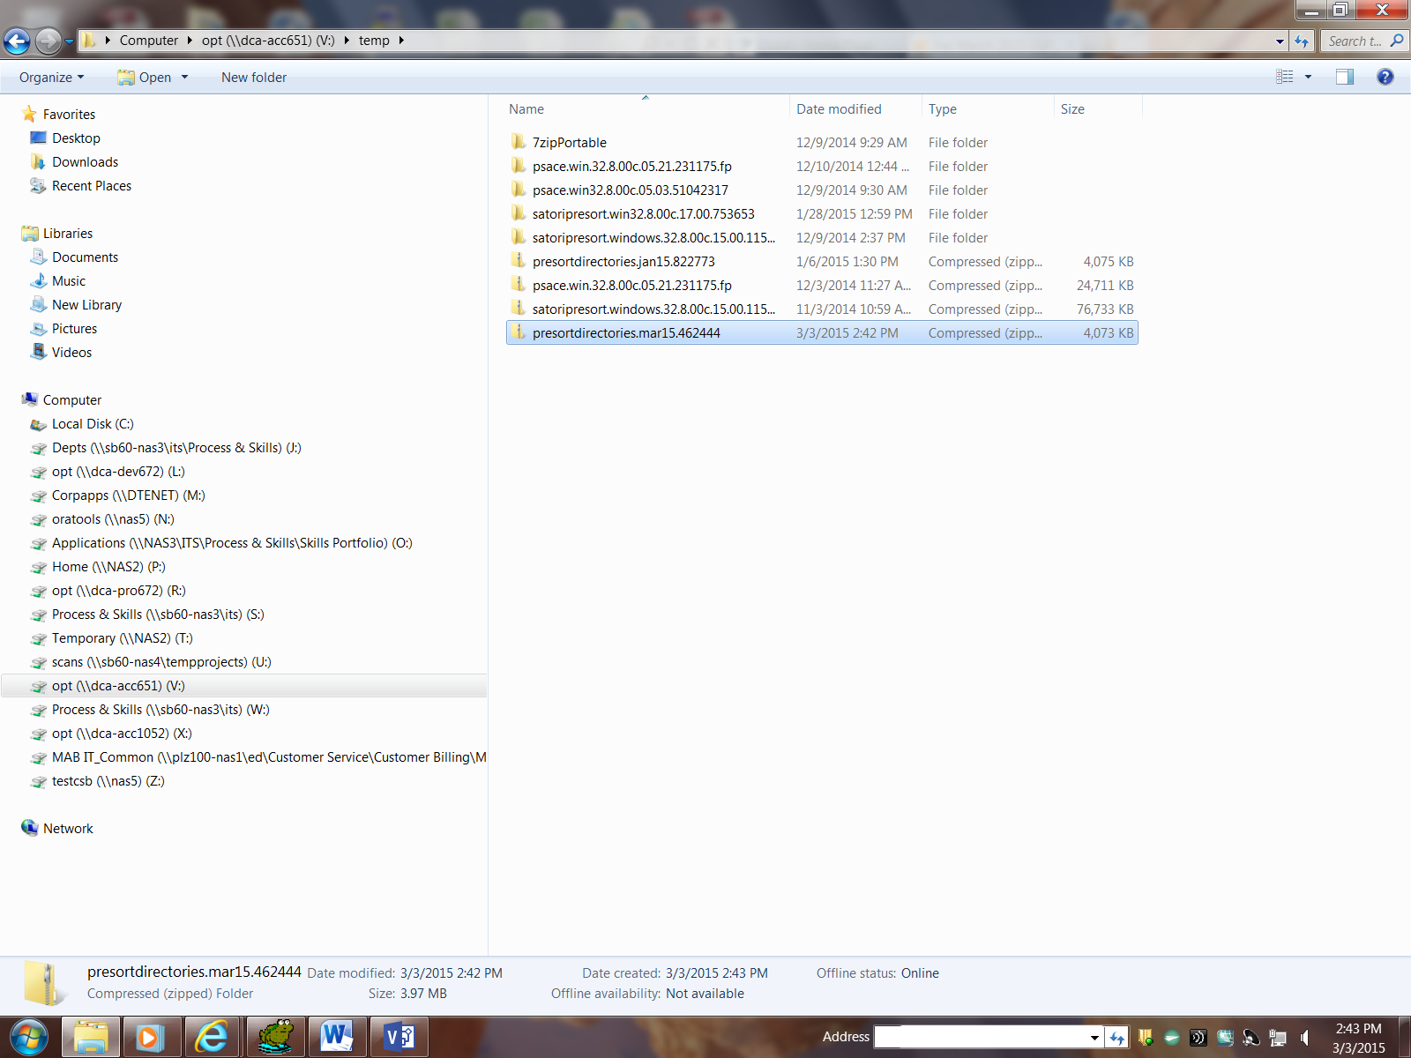

2. Click on 7zipportable.exe

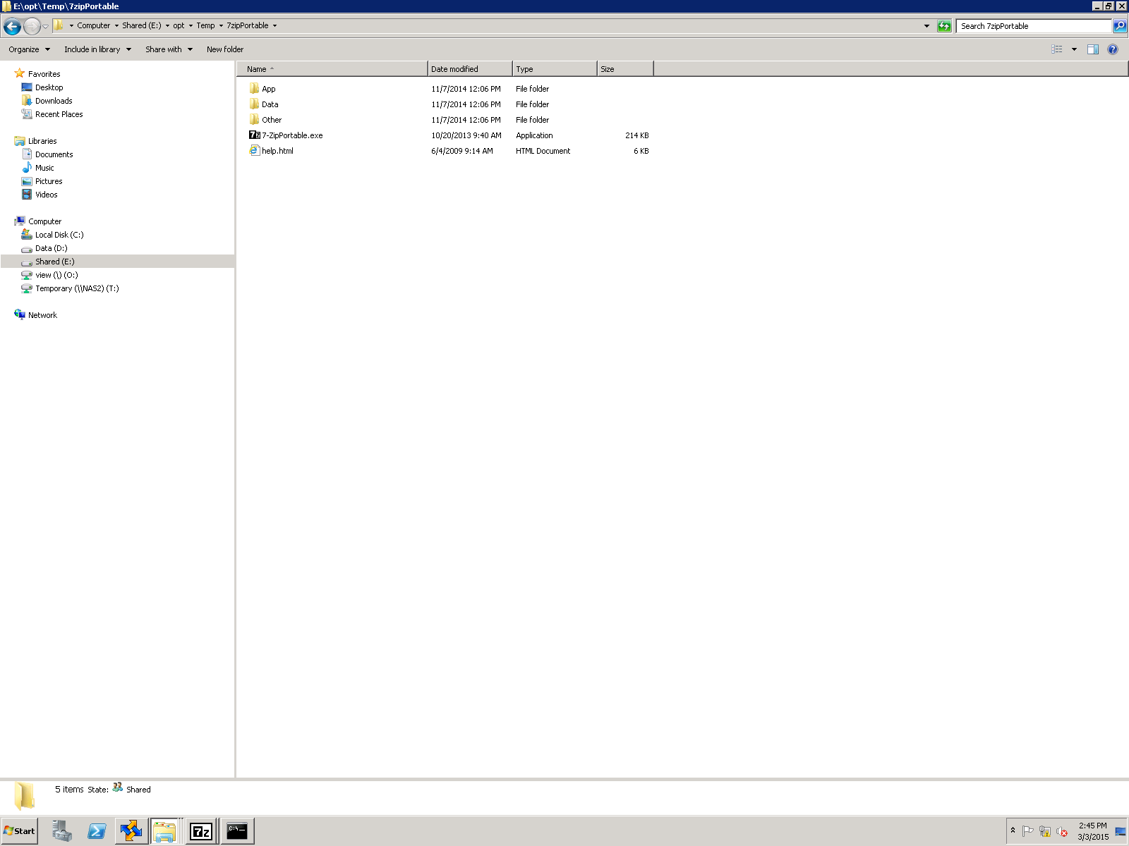

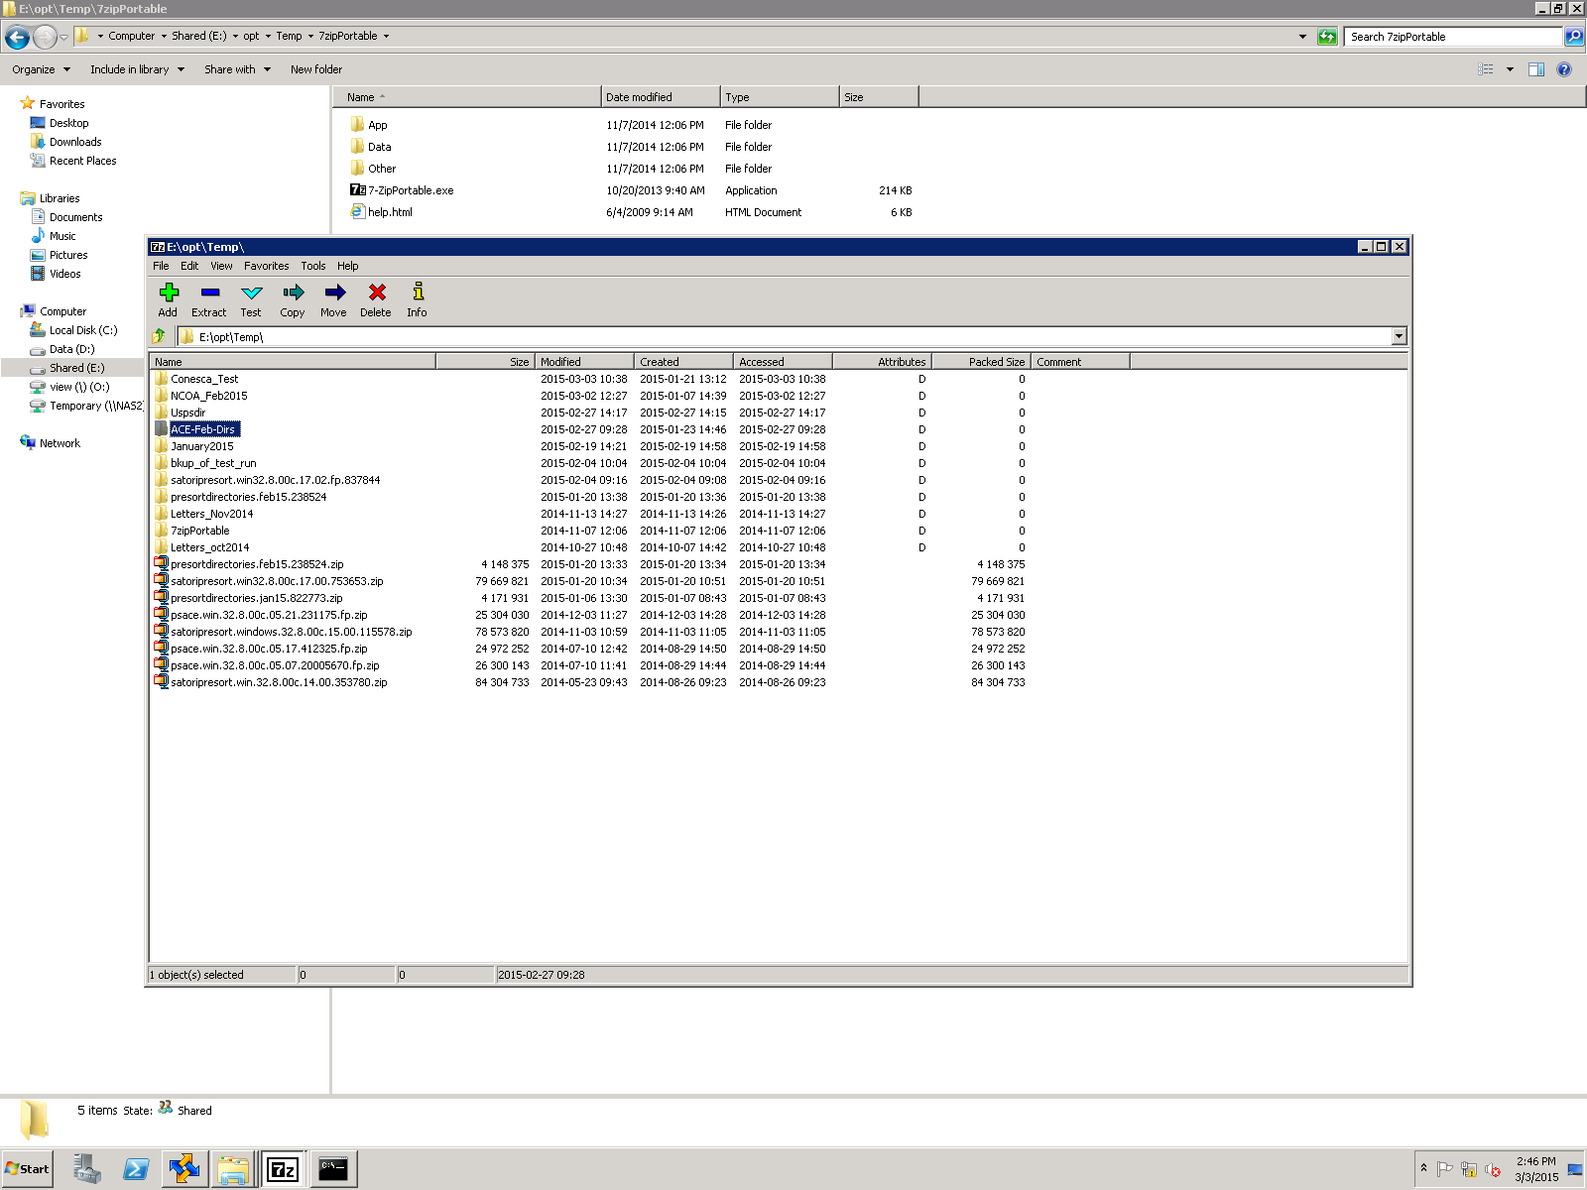

3.Unzip the file using 7-Zip and extract the file.

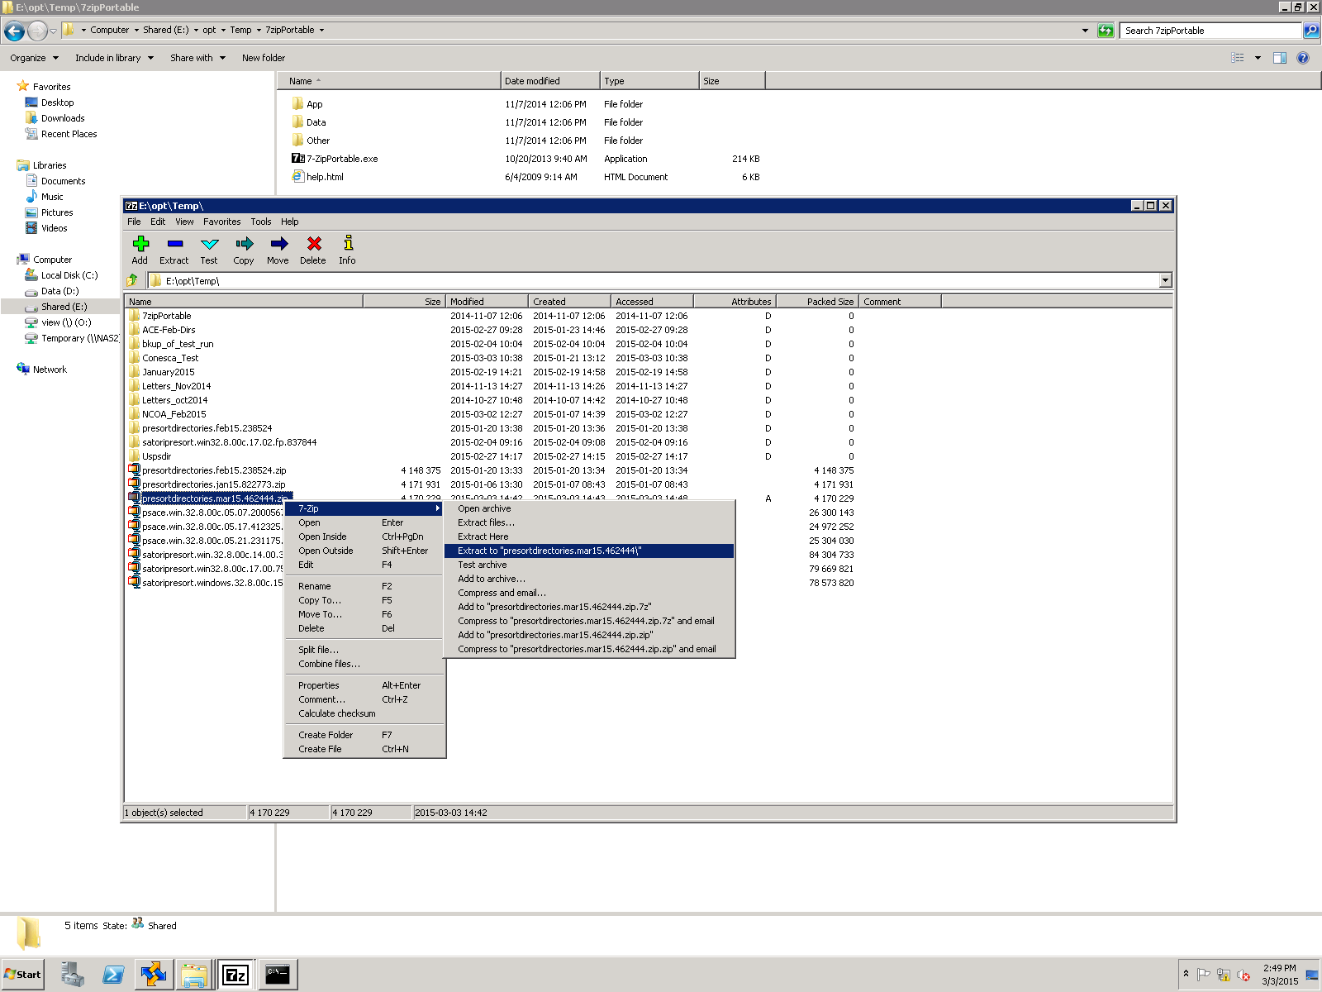

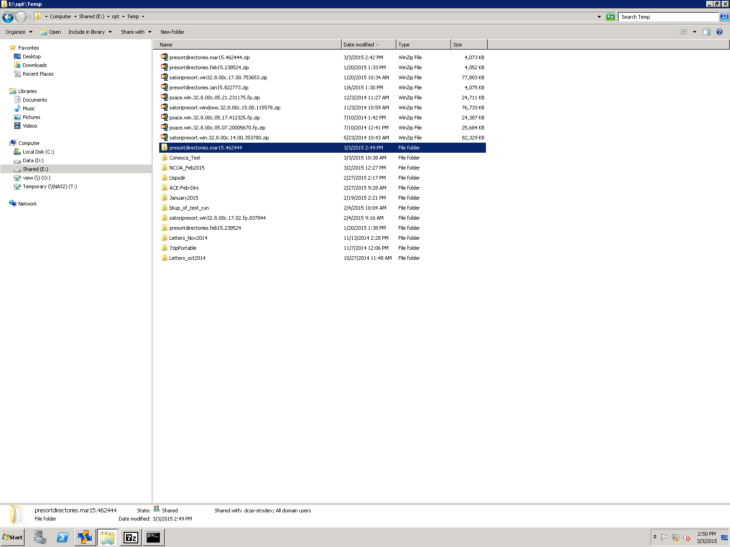

4. Login to the Data Services DEV (dca-dev1121) box and open the presort directory and verify the files. Open the D: Directory and delete the SS-copy folder. Copy the SS folder and paste on Blank place.it should create the folder SS-copy

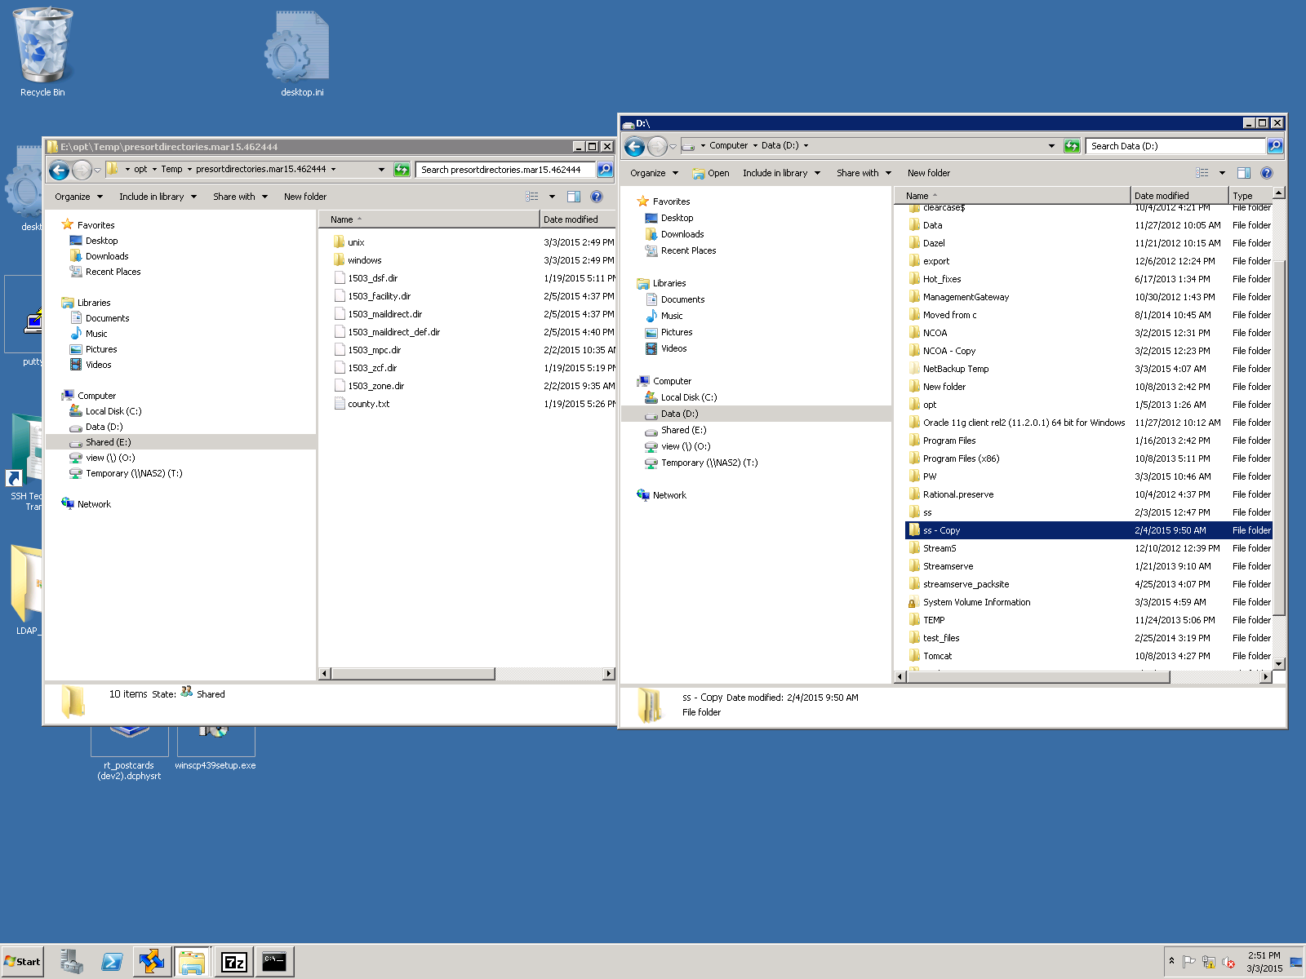

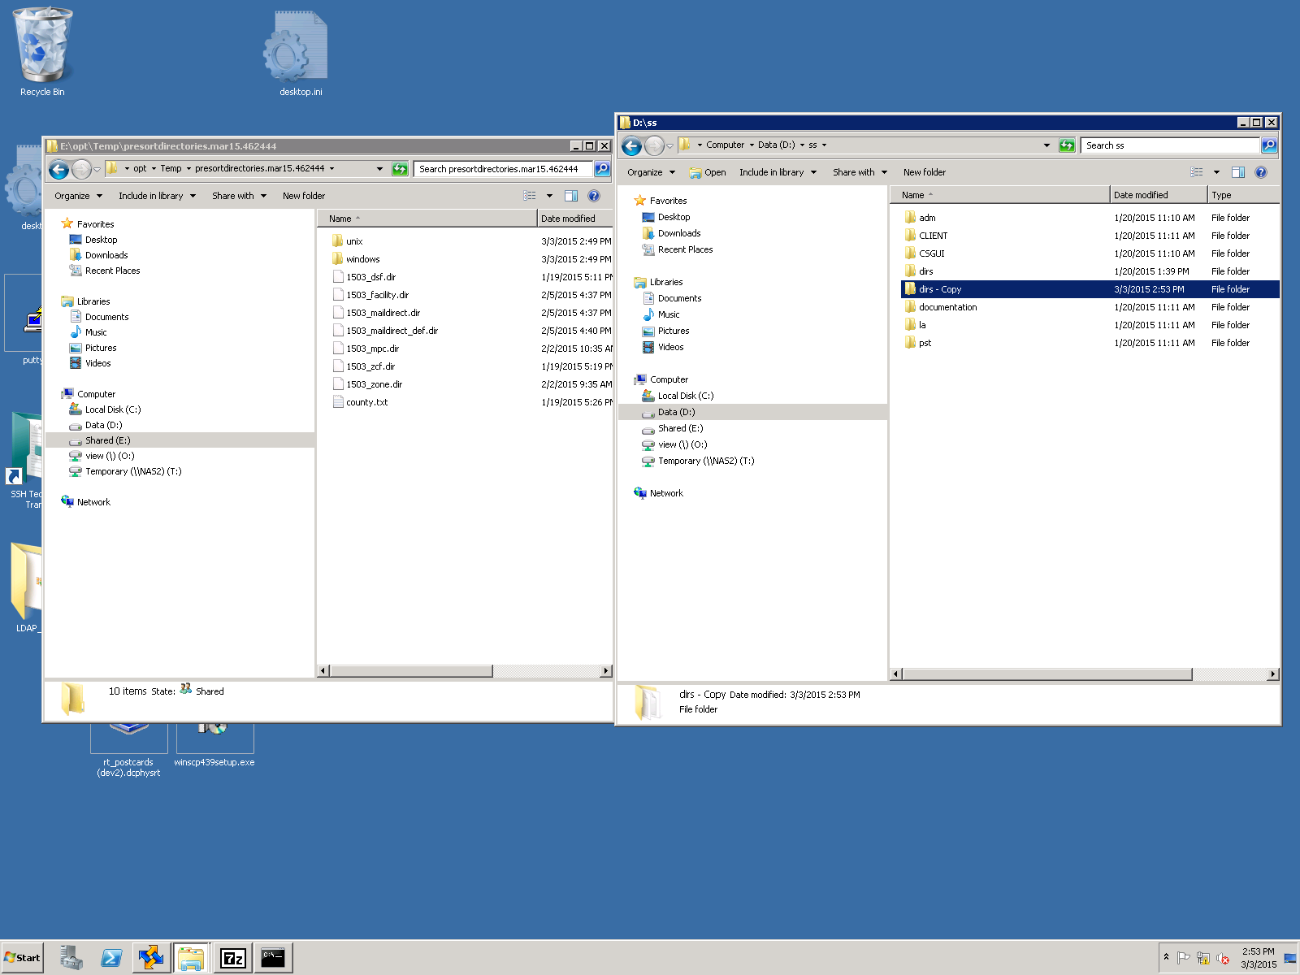

6.open the DIR folder from D:\ss\dir

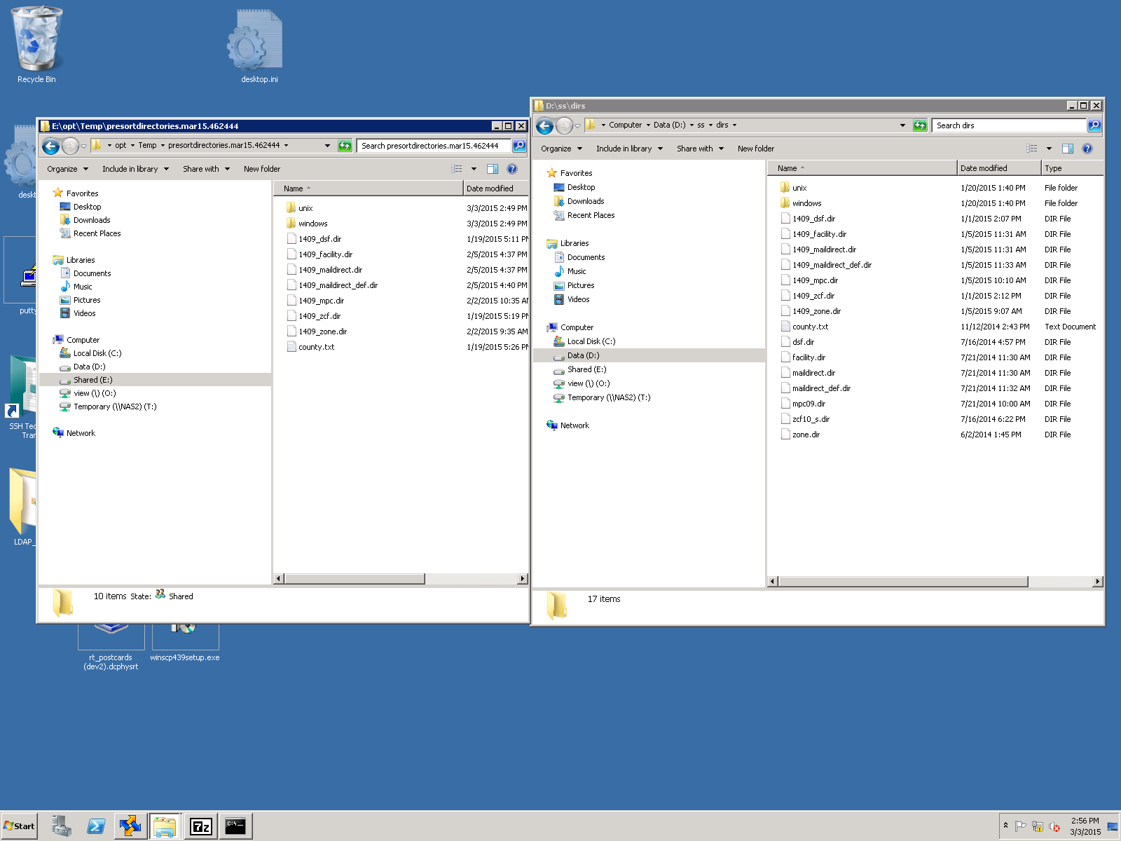

7. Rename the files from uncompressed folder E:\opt\temp\pereort directories.mar15.. 1503 to 1409_name.for example in the above step

We have renamed 1503_dsf.dir to 1409_dsf.dir.Change the entire file names with 1409.

8. Copy the files from E:\opt\temp\pereort directories.mar15.. Folder and paste in D:\SS\Dir folder

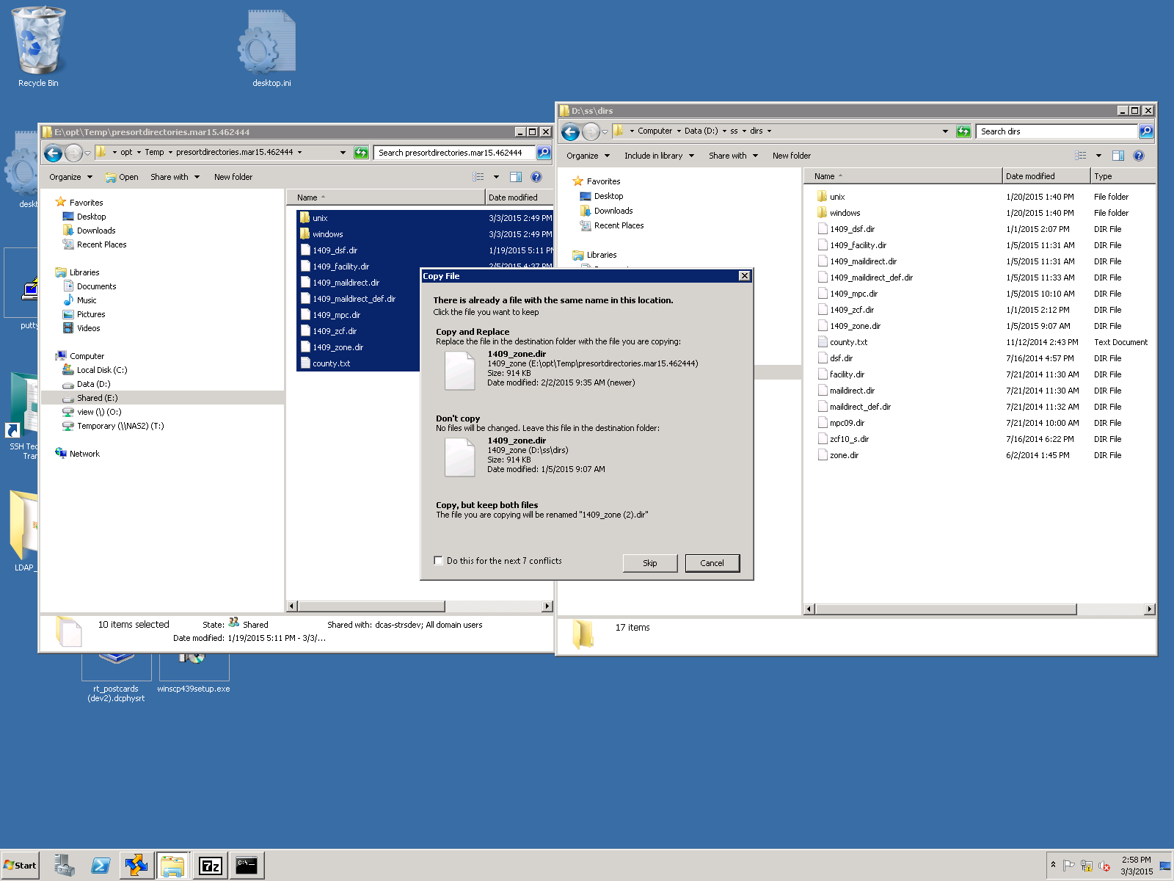

9. Select the check box and click yes twice

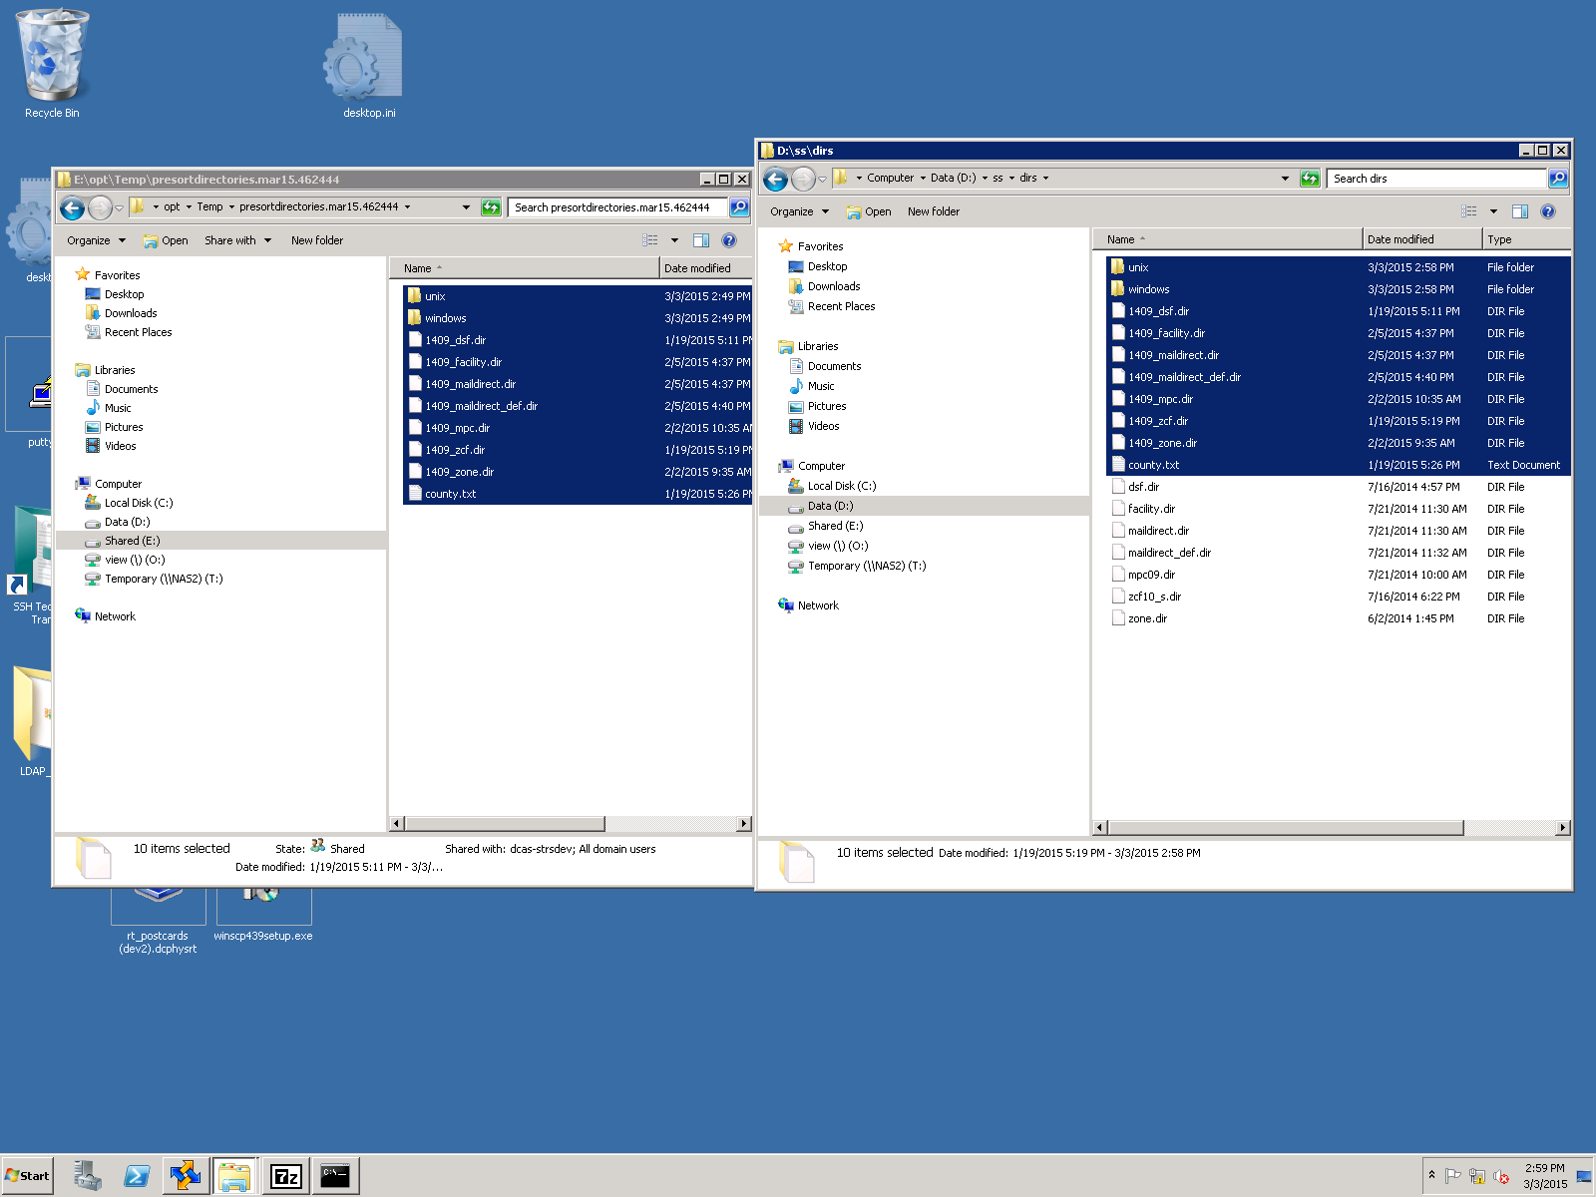

10. Run the test in dev. Copy the POF files from last night’s production and rerun the process of postal optimization.

Change the names of the Production files according to the following screenshot before moving them to StreamServe DEV box:

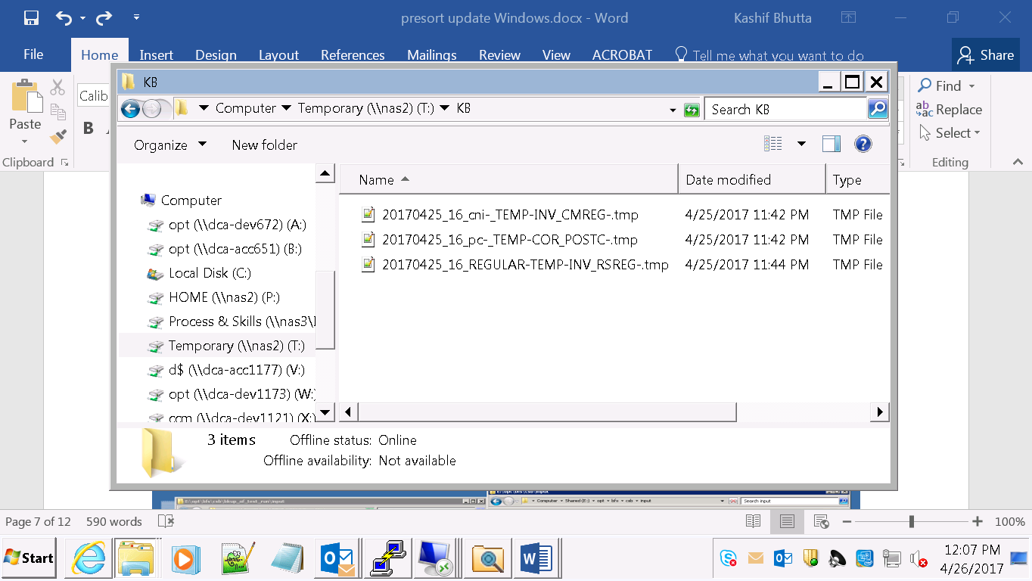

Move these files to StreamServe dev folder to be processed. Run the DS job as in the following screenshot.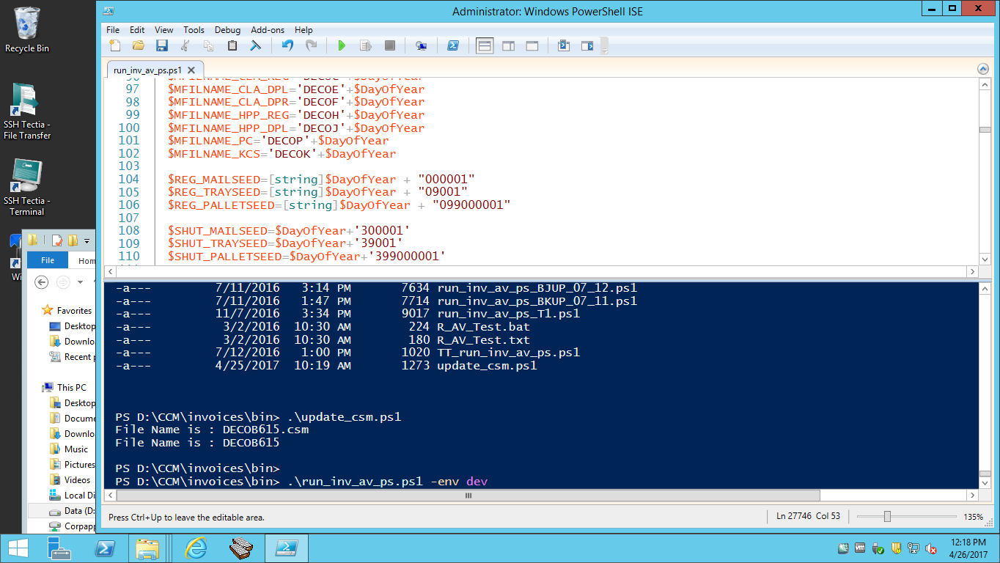

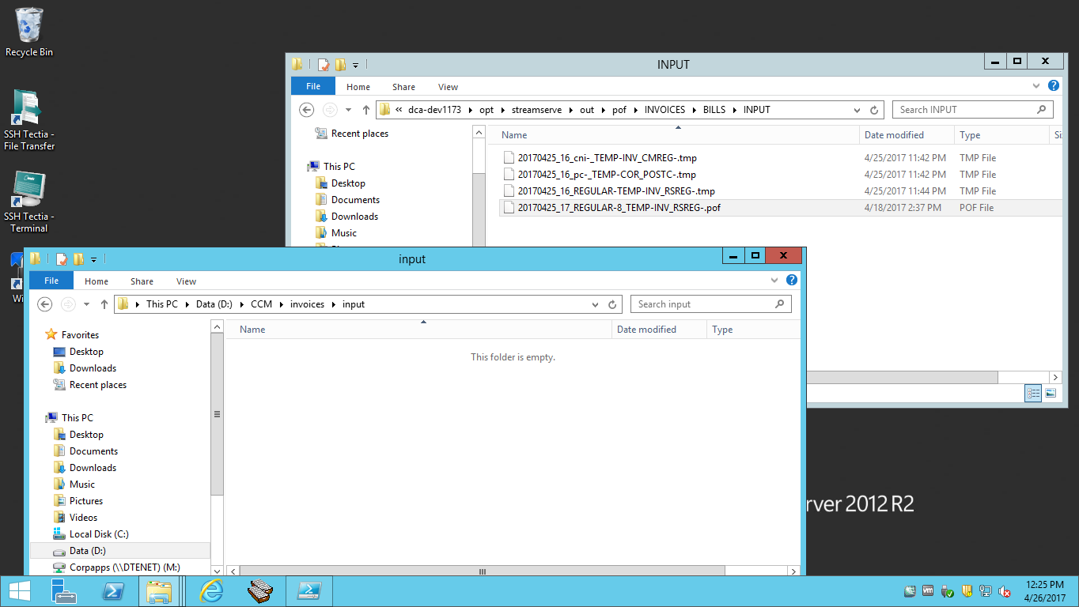

Once we verify that the Process has completed successfully and our reports including DECO* reports are available for viewing, the update of presort monthly directories successfully tested. This test can be performed even with one POF file (preferably regular invoices file). Paste the process.done file for process to exit.